Propel Montour 8th Grade Trip Fundraiser
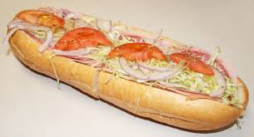Bowser’s Hoagies / Pepperoni Rolls 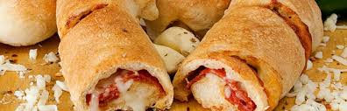
Who: All Propel Montour 8th Grade Students
When: Sell Jan. 12-26
Orders due (whole order form)by Jan. 27 with payment
(checks made payable to Propel Montour)
Pick-up: Monday, February 6 @ 3:30
What: Bowser’s Hoagies/Pepperoni Rolls
Why: Raise money for the 8th Grade Trip to Washington DC
*Students will bank approx. 40% of total amount sold in their individual accounts
Propel Montour is a Title I School

